‘PC Controlled Pick & Place Robotic Arm’

Objective And Scope of the project

The project titled PC Controlled Pick and Place robotic arm is intended to perform basic pick and place of random objects. The main idea behind the project is to control the arm using the PC parallel port. The project involves an in-depth analysis and study in the field of Robotics, Electronics, Mechanical designs and Hardware interfacing. The scope of the project is not just limited to the current system designed but being able to interface the PC parallel port is as good as gaining access to a Pandora’s Box. Using the PC parallel port, ‘Sky is the limit for your imagination’.

Various aspects need to be taken care of while dealing with a Robotics project. The electrical design circuits need to be learned in detail. The mechanical design and the structure of the system have to be planned. Integration of the mechanical and electrical parts is of utmost importance. Both the designs should complement each other.

The system works on 3 stepper motors which can be programmatically controlled using the software designed and the PC’s parallel port. The software enables the user to choose between the various stepping modes and then steer the arm to a desired location. The software also consists of a video feed from a USB webcam mounted at a strategic location so as to give a complete view of the field. The user can look at this video field and maneuver the arm accordingly.

The GUI design for the software is created using Java Swing. The DLL’s to interface with the PC’s parallel port are coded in Visual C++ (VC++). The GUI and the DLL’s are integrated using Java Native Interface (JNI). The video feed from the USB webcam is captured using Java Media Framework (JMF).
An introduction and a brief overview to each of the above mentioned technologies can be found in this documentation.

Introduction to Robotics and Overview

Robotics is the science and technology of robots, their design, manufacture, and application. Robotics requires a working knowledge of electronics, mechanics and software, and is usually accompanied by a large working knowledge of many subjects.
Although the appearance and capabilities of robots vary vastly, all robots share the features of a mechanical, movable structure under some form of autonomous control. The structure of a robot is usually mostly mechanical and can be called a kinematic chain (its functionality being akin to the skeleton of the human body). The chain is formed of links (its bones), actuators (its muscles) and joints which can allow one or more degrees of freedom. Most contemporary robots use open serial chains in which each link connects the one before to the one after it. These robots are called serial robots and often resemble the human arm.

REASONS FOR USING A ROBOT: -

The reasons for introducing the robot into production process could be:
- It relieves man of hazardous or fatiguing tasks.
- It brings improvements in products constituency and quality.
- A robot can perform work in repetitive work cycle i.e. multishift operation.
- A robot can sustain in frequent change over between work cycles.
- In countries short of labour, it brings in savings from labour reduction. It increases the output without increasing the labour force.
- Robots lead the way into areas of technology where man has not entered yet.
- Mobile robots with moving arms and wide sensing power will find more applications in the future world.

GENERAL APPLICATIONS OF ROBOT: -
Industrial robot applications usually involve several pieces of hardware (conveyors, pallets, machine tools, fixtures, etc.)
In addition to the robot, several robot and associated hardware may have to be integrated into a single work cell. Layout of the equipment in the cell deserves greater attention for optimum results. Various types of layout may involve centring on single robot, various robots arranged in line, or robots may be mobile. In manufacturing application, robots may be used to handle tools and work pieces, processing operations, assembly and inspection.
Robots today, find wide applications in processes like welding, material handling (packing, transport of various parts and warehousing), painting assembly (such as insertion, stacking, tightening etc, all calling for greater positioning accuracy and repeatability), foundry, machine loading, and inspection. Their used can be such on large scale in automobiles and electronics industries.

ADVANTAGES AND ECONOMICS OF ROBOTS: -
The rising labour cost, safety requirements and capability to work in tough environments have given a boost to applications of robots. It must be remembered that robots helps in building greater flexibility into the existing production system, this results in increased turnover and better return on investment due to their inherent ability to work at optimal rate with unfailing repeatability and speed, achieving less rejection due to relieving of workers from tough tasks.
The industrial robot can do a human’s work much more effectively. They do not take breaks or go on strike, and they know neither wearing loss nor boredom.
Nevertheless, the better quality of products achieved by the robot operations rather than the higher productivity is sometimes regarded as the most important contribution of robots. When robots are used in industry, the product quality is more constituent and quality control is simpler.
Industrial robots are ideally suited for jobs, which are regarded as unpleasant or unhealthy for people. Spray painting, for example is unhealthy for operators who breathe toxic air. These operators would be happy to be moved to less hazardous assignments when spray painting robots replace them by emulating the operator’s motions.
Robots are ideal for any repetitive job, which is regarded as too boring or too tedious for human operators. In many assembly lines the production process consists of numerous assembly tasks, each of a limited number of operations, which require unskilled labour. Robots can be easily integrated into such processes and do the job more effectively than people. In short robots enable the use of people to the best.
The principal advantages of industrial robots can be summarized as follows: -
- Flexibility
- High productivity
- Better quality products
- Improved quality of human life by performing the undesirable jobs

Many industrial leaders perceive the robot only as a programmable machine that can replace workers. But the key issue is not putting a robot in a shop to do the work of two persons. It is the flexibility of the robot, which enables its use as a tool in the factory in the future.
In the factory of the future, raw materials will be transformed into finished products completely by automation. Every operation in this future factory right from the product design and manufacturing to assembly and production will accomplish with the use of robots. Also inspection will be monitored and controlled by computers and performed by robots and artificial intelligence (A.I.) systems.
An important aspect of this factory of the future will be its manufacturing flexibility. By simply changing the computer program and an appropriate simple setup, one will be able to change the factory’s finished product.
The flexibility of the factory gives the company greater freedom to meet different specifications for a given products and to introduce new models more quickly.

ROBOT TYPES AND THEIR CLASSIFICATION: -
To understand how a robot works it is determined how it moves. There are two basic movements by robots:
- Transverse
- Rotational
The transverse movement is either a linear movement of a beam in a fixture or a telescopic movement. A rotational movement is a pivot or a hinge.
The degree of freedom for a robot is a good measure for how complicated the robot is and thereby how complicated it is to control. If a robot has more than three degrees of freedom there are several ways a given point in space can be reached. This complicates the control of the robot significantly. When the robot has six or more degrees of freedom, a given point in space can be reached with the end effector pointing in any direction. This is only if the degrees of freedom are not causing the same movements and if the point is within the robot’s workspace.
The workspace consists of the points that the end effector can be directed. The table below shows workspaces for different types of robots and their classification.

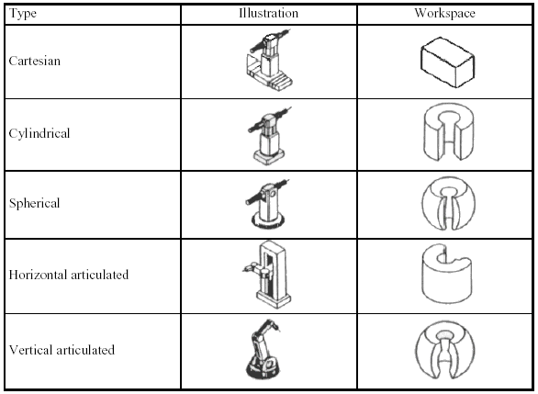
(Table 1: Robot Classification based on Workspace geometries)
Plan of Development

- After taking up the project in robotics a variety of ideas could have been implemented. The most common one’s being to construct a grid solving robot or a line follower robot. However the idea of constructing a robotic arm to pick and place objects was all the more fascinating.
- The challenge in constructing the robotic arm was more since it required complex electrical and mechanical designs.
- It was decided to construct a 3 DOF robotic arm which could be able to manipulate objects in the XY plane.
- For the robot to be able to manipulate objects in the XY plane a suitable design was required.
- Also the types of motors to be used and the number of motors required to achieve the objective was decided.
- The robot would be controlled by PC parallel port, so a suitable kernel mode device driver was required to interface the hardware.
- Based on the selection of motors the entire circuitry was planned and tested.

BASIC ELEMENTS OF A ROBOT: -
The basic elements of industrial robots are manipulator, controller, end-effecter, and energy sources.
The manipulator comprising of base, arm and wrist are the most obvious parts of the robots. The robots movements are executed by the mechanical parts like links and power joints.
The controller acts like a brain of robot. It performs the functions of storing and sequencing data in memory, initiating and stopping the motions of the manipulator and interacting with the environment.
End-effecter is the tool, a sort of gripper, which directly interacts with the job. Grippers are being designed to handle a wide range of part configuration.
Energy sources required causing movement of the manipulator arm. They may take the form of electrical, hydraulic or pneumatic devices.

JOINTS: -
A joint permits relative motion between two links (or arms) of a robot. It provides controlled relative movement between two (input and output) links. Usually one joint provides the robots with one degree of freedom.

ROBOT ARMS: -
The simplest arm is “pick and place type”. The case parts are moved from one location to another without carrying how the part is picked up or complicated shapes and fragile in nature. These may be used to assemble the parts or fit them into clamp and fixture.

DRIVES AND CONTROL: -
Every axis of the robot manipulator includes a device, which converts the electrical command signals of the computer to mechanical motions. Drives for computerized robot system are usually hydraulic or electrical stepper motors. The allowable speed of a stepping motor is a function of its load torque, but the latter strongly depends on the arm position and the gripper load.

Stepper Motors in Detail

In Theory, a Stepper motor is a marvel in simplicity. It has no brushes, or contacts. Basically it's a synchronous motor with the magnetic field electronically switched to rotate the armature magnet around.

Definition
A stepper motor is basically an electromechanical device which converts electrical pulses into discrete mechanical movements. The shaft or spindle of a stepper motor rotates in discrete step increments when electrical command pulses are applied to it in the proper sequence. The motors rotation has several direct relationships to these applied input pulses. The sequence of the applied pulses is directly related to the direction of motor shafts rotation. The speed of the motor shafts rotation is directly related to the frequency of the input pulses and the length of rotation is directly related to the number of input pulses applied.

Characteristics:
• Holding Torque - Steppers have very good low speed and holding torque. Steppers are usually rated in terms of their holding force (oz/in) and can even hold a position (to a lesser degree) without power applied, using magnetic 'detent' torque.
• Open loop positioning - Perhaps the most valuable and interesting feature of a stepper is the ability to position the shaft in fine predictable increments, without need to query the motor as to its position. Steppers can run 'open-loop' without the need for any kind of encoder to determine the shaft position. Closed loop systems- systems that feed back position information, are known as servo systems. Compared to servos, steppers are very easy to control; the position of the shaft is guaranteed as long as the torque of the motor is sufficient for the load, under all its operating conditions.
• Load Independent - The rotation speed of a stepper is independent of load, provided it has sufficient torque to overcome slipping. The higher rpm a stepper motor is driven, the more torque it needs, so all steppers eventually poop out at some rpm and start slipping. Slipping is usually a disaster for steppers, because the position of the shaft becomes unknown. For this reason, software usually keeps the stepping rate within a maximum top rate. In applications where a known RPM is needed under a varying load, steppers can be very handy.

Types of stepper motors

TYPES OF STEPPER MOTORS
Stepper motors fall into two basic categories: Permanent magnet and variable reluctance. The type of motor determines the type of drivers, and the type of translator used. Of the permanent magnet stepper motors, there are several "subflavors" available. These include the Unipolar and Bipolar varieties.

• Permanent Magnet Stepper Motors
Unipolar Stepper Motors
Unipolar motors are relatively easy to control. Unipolar stepper motors are characterized by their center-tapped windings. A common wiring scheme is to take all the taps of the center-tapped windings and feed them +MV (Motor voltage). The driver circuit would then ground each winding to energize it.
Unipolar stepper motors are recognized by their center-tapped windings. The number of phases is twice the number of coils, since each coil is divided in two.
Identifying the wires in Stepper Motors
- A stepper motor with 5 wires is almost certainly 4-phase unipolar.
- A stepper motor with 6 wires is probably also 4-phase unipolar, but with two Common Power wires. They may both be the same colour.
- A stepper motor with only 4 wires is most likely bipolar.

There are two stages to sorting out which wire is which in a 5- or 6-wire unipolar stepper motor:
- Isolate the Common Power wire(s) by using an ohmmeter to check the resistances between pairs of wires. The Common Power wire will be the one with only half as much resistance between it and all the others.
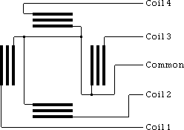
This is because the Common Power wire only has one coil between it and each other wire, whereas each of the other wires have two coils between them. Hence the resistance is half.
- Identify the wires to the coils by supplying a voltage on the Common Power wire(s) and keeping one of the other wires grounded while grounding each of the remaining three wires in turn and observing the results.

The process to identify stepper motor wires:
Select one wire and ground it. Assume it's connected to coil 4 | 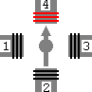
Keeping it grounded, ground each of the other three wires one by one
Grounding one wire should make the rotor turn a little clockwise. That'll be the wire connected to Coil 3 | 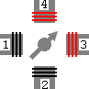
Grounding one wire should make the rotor turn a little anticlockwise. That'll be the wire connected to Coil 1 | 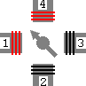
Grounding one wire should do nothing. That'll be the wire connected to Coil 2 | 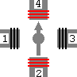
- Note:
The numbering of the coils as above is purely arbitrary - it's the order they are in that's important.

Stepper Motor Drive Sequences /Modes:
The driving sequence or mode of a stepper motor refers to the different ways in which a stepper motor can be controlled. The different sequences vary in the way pulses are fed to the stepper motor. They also differ in the resolution (step angle) and the torque in each mode is different. There exist three different stepping modes for a stepper motor:
- Single Step
The simplest stepping mode is called Single-Stepping. In this mode, each successive coil is energized and the motor moves one full step at a time. For example, my motor will make a full step of 1.8 degrees whenever the coils are energized in the following sequence (D0 - D3 represent parallel port data pins):
Step No. | D0 | D1 | D2 | D3
1 | 1 | 0 | 0 | 0
2 | 0 | 1 | 0 | 0
3 | 0 | 0 | 1 | 0
4 | 0 | 0 | 0 | 1

- Half Stepping
Another interesting stepping mode is Half-Stepping. The difference between single-stepping and half-stepping is that for the same step rate, half-stepping gives you half the speed but twice the resolution of a single step. Since my motor has a step angle of 1.8 degrees, half-stepping it would result in approximately 0.9 degrees of rotation. Here's the sequence in which coils are energized for half-stepping:
Step No. | D0 | D1 | D2 | D3
1 | 1 | 0 | 0 | 0
2 | 1 | 1 | 0 | 0
3 | 0 | 1 | 0 | 0
4 | 0 | 1 | 1 | 0
5 | 0 | 0 | 1 | 0
6 | 0 | 0 | 1 | 1
7 | 0 | 0 | 0 | 1
8 | 1 | 0 | 0 | 1

- High Torque Stepping
In the high-torque sequence, two windings are active at a time for each motor step. This two-winding combination yields around 1.5 times more torque than the standard sequence, but it draws twice the current. Here's how high torque stepping works:
Step No. | D0 | D1 | D2 | D3
1 | 1 | 1 | 0 | 0
2 | 0 | 1 | 1 | 0
3 | 0 | 0 | 1 | 1
4 | 1 | 0 | 0 | 1

A sample circuit to drive stepper motor using your PC parallel port is given below:
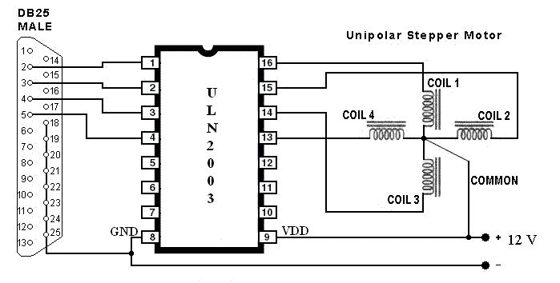
The above circuit uses the ULN2003 driver IC. Inputs to this IC are given using PC’s parallel port. The details of sending pulses using PC parallel port are given in the sections ahead. The specifications for each stepper motor used can be found in the electrical specifications section.
Parallel Port Basics
Parallel port is a simple and inexpensive tool for building computer controlled devices and projects. The simplicity and ease of programming makes parallel port popular in electronics hobbyist world. The parallel port is often used in Computer controlled robots, Atmel/PIC programmers and home automation.
The parallel port can be found behind your PC and looks something like in the image below. It is a 25 pin female (DB25) connector (to which printer is connected). On almost all the PCs only one parallel port is present, but you can add more by buying and inserting ISA/PCI parallel port cards.
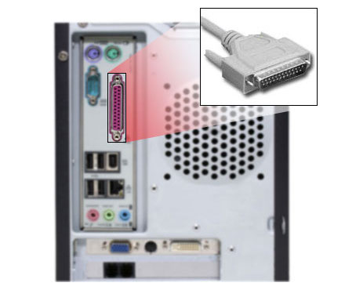
Hardware
The pin outs of DB25 connector is shown in the picture below
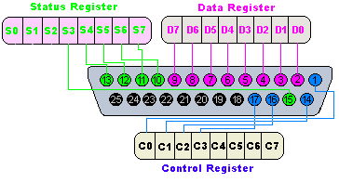
The lines in DB25 connector are divided in to three groups, they are
1) Data lines (data bus)
2) Control lines
3) Status lines
As the name refers, data is transferred over data lines, Control lines are used to control the peripheral and of course, the peripheral returns status signals back to the computer through Status lines. These lines are connected to Data, Control and Status registers internally.

The details of parallel port signal lines are given below
Pin No (DB25) | Signal name | Direction | Register - bit | Inverted
1 | nStrobe | Out | Control-0 | Yes
2 | Data0 | In/Out | Data-0 | No
3 | Data1 | In/Out | Data-1 | No
4 | Data2 | In/Out | Data-2 | No
5 | Data3 | In/Out | Data-3 | No
6 | Data4 | In/Out | Data-4 | No
7 | Data5 | In/Out | Data-5 | No
8 | Data6 | In/Out | Data-6 | No
9 | Data7 | In/Out | Data-7 | No
10 | nAck | In | Status-6 | No
11 | Busy | In | Status-7 | Yes
12 | Paper-Out | In | Status-5 | No
13 | Select | In | Status-4 | No
14 | Linefeed | Out | Control-1 | Yes
15 | nError | In | Status-3 | No
16 | nInitialize | Out | Control-2 | No
17 | nSelect-Printer | Out | Control-3 | Yes
18-25 | Ground | - | - | -
Parallel port registers
As you know, the Data, Control and status lines are connected to there corresponding registers inside the computer. So by manipulating these registers in program, one can easily read or write to parallel port with programming languages.
The registers found in standard parallel port are,
1) Data register
2) Status register
3) Control register
As there names specifies, Data register is connected to Data lines, Control register is connected to control lines and Status register is connected to Status lines. (Here the word connection does not mean that there is some physical connection between data/control/status lines. The registers are virtually connected to the corresponding lines.). So what ever you write to these registers, will appear in corresponding lines as voltages, Of course, you can measure it with a multimeter and what ever you give to Parallel port as voltages can be read from these registers (with some restrictions). For example, if we write '1' to Data register, the line Data0 will be driven to +5v. Just like this, we can programmatically turn on and off any of the data lines and Control lines.

Where these registers are?
The registers are IO mapped and will have unique address. We have to find these addresses to work with parallel port. For a typical PC, the base address of LPT1 is 0x378. The data register resides at this base address, status register at baseaddress + 1 and the control register is at baseaddress + 2. So once we have the base address, we can calculate the address of each registers in this manner. The table below shows the register addresses of LPT1 and LPT2 used in the project.
Note: 4 data pins can control a single motor and this system makes use of 3 stepper motors. So an additional PCI => Parallel Card was required.
Register | LPT1 |  | LPT2
 | Hexadecimal | Decimal | Hexadecimal | Decimal
data register(baseaddress + 0) | 0x378 | 888 | Ex480 | 58496
status register (baseaddress + 1) | 0x379 | 889 | Ex481 | 58497
control register (baseaddress + 2) | 0x37a | 890 | Ex482 | 58498

Overall System Design and Specifications
The overall system design and specification for the PC controlled pick and place robotic arm can be characterized into the following categories:
- The robotic arm mechanical and electrical design and specifications.
- The robotic arm electrical design and specifications.
- The software design and development for the robotic arm.

- The robotic arm mechanical design and specification.
The mechanical design of the system was a crucial part towards completion of the project. During the mechanical deign phase various ideas were thought and implemented in-order to find a perfect blend for the system.
An important aspect was the materials to be used for designing the links for the arm. Out of the few options, materials like Acrylic sheets and aluminum were considered. The links for the system were designed using aluminum at first. The design was cut out from aluminum sliding window strips and attached to the motor. However the initial tests failed the use of this material as there was lot of arm sagging involved. Though aluminum was very light weighed it couldn’t suffice the requirement. A similar problem was observed with acrylic sheets. Also cutting the sheets and parts from these materials was not possible.
The next approach was to opt for wood or stainless steel for the links of the arm. In-order to cut the parts out the stainless steel strips help was taken from a turner. The dimensions for the links were decided and each individual link was fixed over the stepper motors.
The stepper motors were arranged and aligned in such a manner so as to give the yaw motion in X direction using the base stepper motor and a pitch motion in the Y direction using the Shoulder stepper motor. The gripper motor was fixed directly to the output shaft of the shoulder stepper.
The base stepper needed to be mounted on a suitable base and the whole weight of the assembly had to be countered so as to prevent it from toppling over. The base was designed using wooden pieces which were screwed to a wooden plank. The base stepper was placed at the far end of this wooden plank. This arrangement countered the weight of the entire assembly. An image of the assembly prepared is shown below. More images can be referred to in the project album.
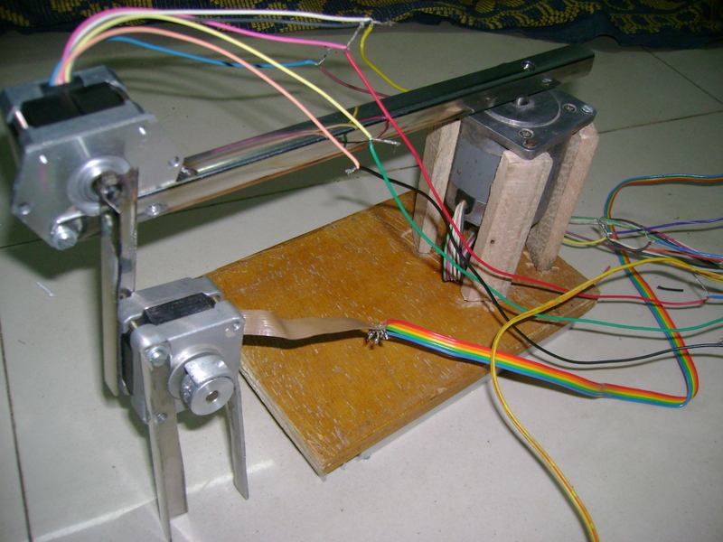
This mechanical design prepared failed for some reasons. A brief overview of which is given towards the end of this documentation. An alternate approach was to disconnect the shoulder motor and use another stepper motor to lift up the gripper motor. The assembly of a fulcrum was thought which would pivot at the end of the link attached to the base motor. A thread was attached to this fulcrum the other end of which was tied to the shaft of the new stepper motor. This motor was placed right above the base stepper motor. This arrangement also reduced the stress on the base stepper. Also to elevate the assembly additional aluminum strips and wooden plank was fixed to the base plank. The gripper was decided to be made of two strips of metal. One strip was fixed to the gripper motor body and another one was glued to the output shaft of the gripper motor. The gripper is able to hold random objects. However due to time constraints and lack of resources the gripper is not generalized for all objects.

The image below shows the final mechanical system design:

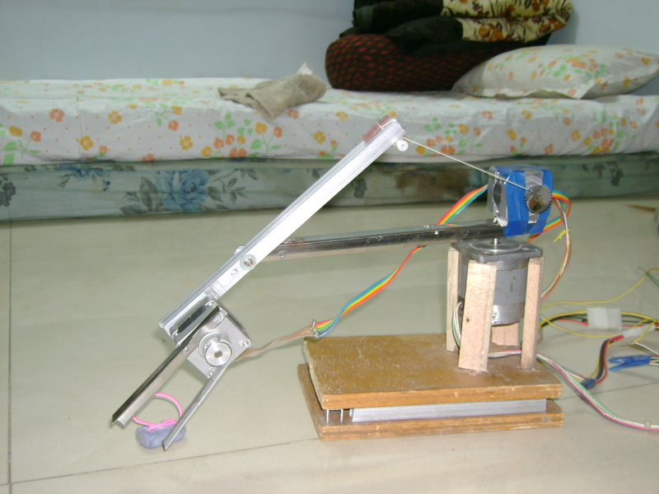
- The Electrical design and development of the system.
As described in the section on Stepper motors above, a sequence of pulses need to be fed to the motors in-order for them to rotate in a particular direction. The output pulses from the PC parallel port cannot be used directly and a current amplifying mechanism is required for this purpose. The 3 stepper motors used in the project operate in the range of +10 to +15 Volts DC. The output from the PC parallel port is a Time to Live (TTL) signal measuring only up to +5Volts. There are various motor driver IC’s which can be used. Each IC has its own unique specification and differs amongst the others either in the pin connections or the amount of current it can give as output. A brief overview of all the IC’s and other electrical components used is given ahead.
  - IC ULN2003
The most common motor driver IC is the ULN2003 IC. The specifications for this are given below:

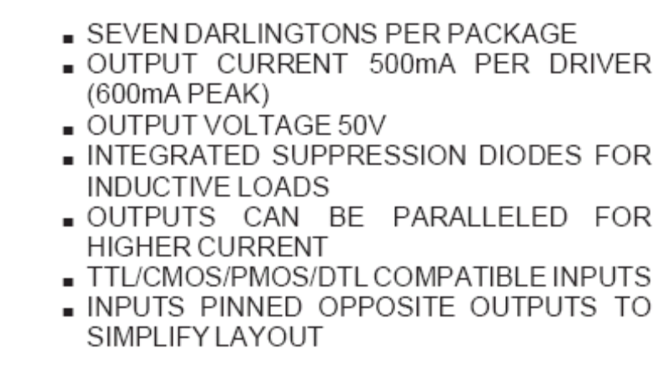

The DIP package is as shown below:
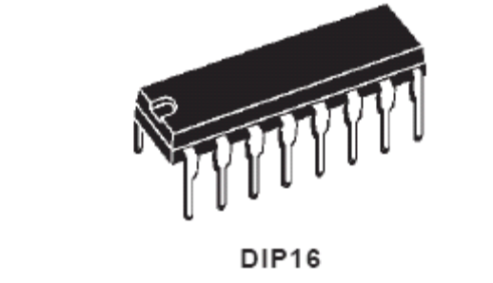
The pin connections for the ULN2003 are as given below:
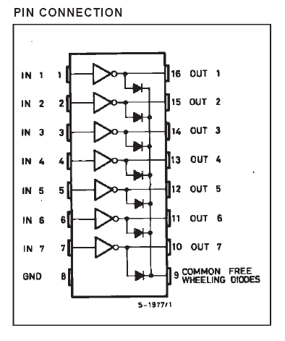
The table below provides the absolute maximum ratings for the ULN2003 IC
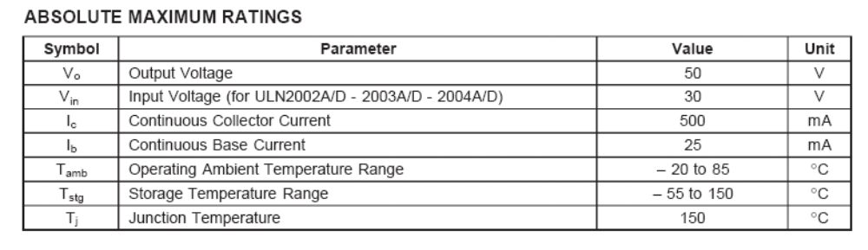
  - IC ULN2803
The basic difference between the ULN2003 and ULN2803 is the number of pins each IC has. While ULN2003 is a 16pin DIP package, ULN2803 is an 18pin DIP package. ULN2003 can drive only one unipolar stepper motor as compared to ULN2803 which can drive a maximum of 2 unipolar steppers.
The specifications of ULN2803 are
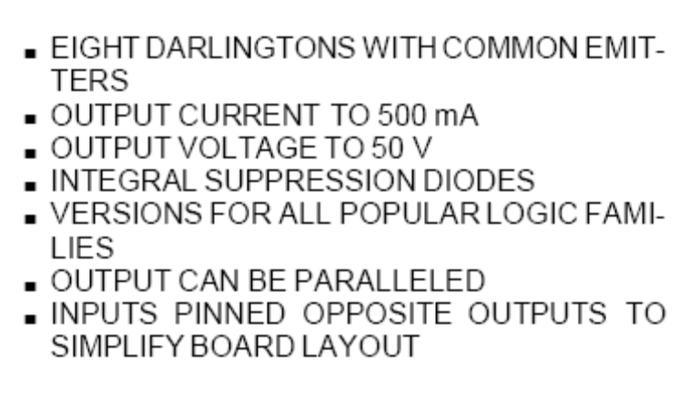

The DIP package for the IC is as shown:
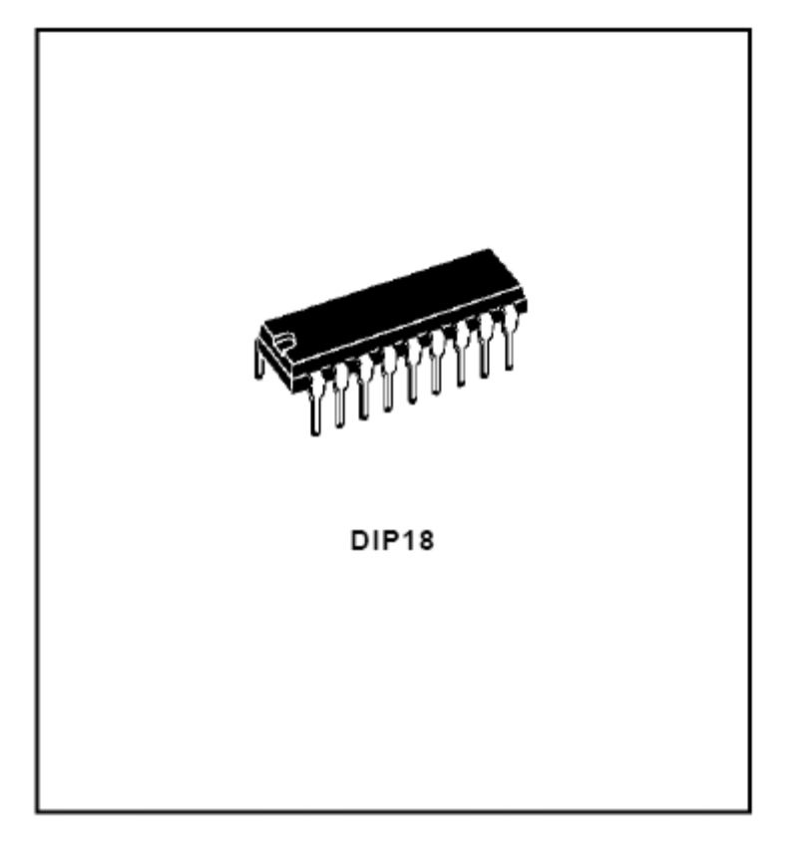
The pin connections for ULN2803 are as given below:
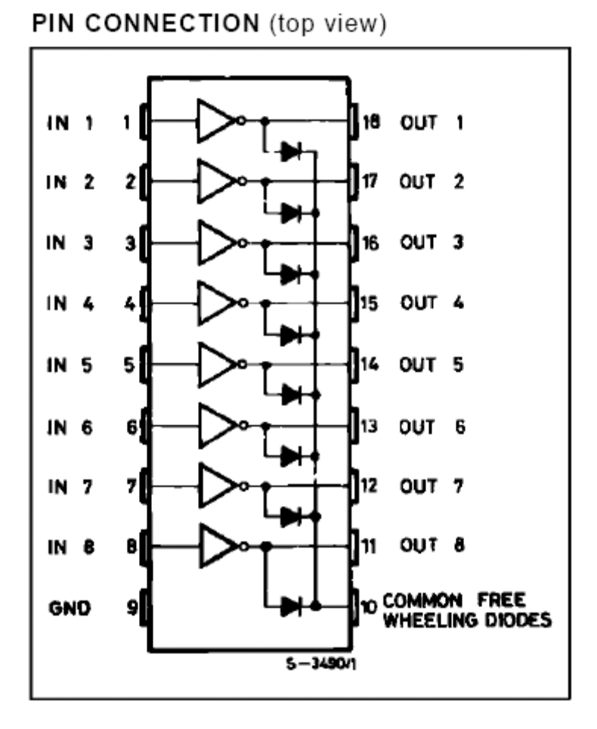
The table below provides the absolute maximum ratings for the ULN2803 IC
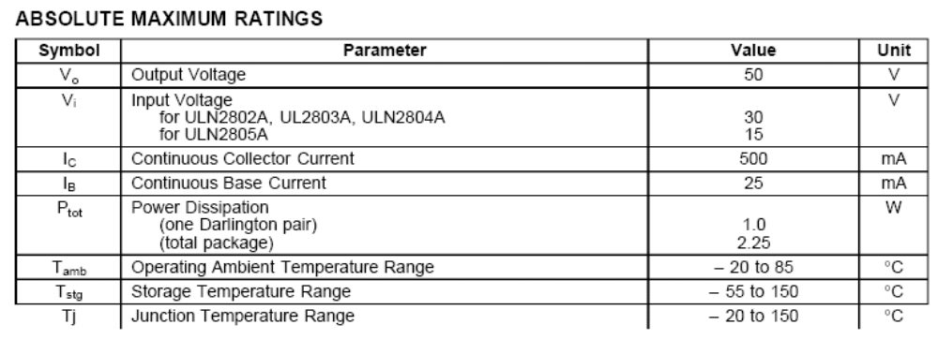
  - IC L293D
The Device is a monolithic integrated high voltage, high current four channel driver designed to accept standard TTL logic levels and drive inductive loads (such as relays, solenoids, DC and stepping motors) and switching power transistors. To simplify use as two bridges each pair of channels is equipped with an enable input. A separate supply input is provided for the logic, allowing operation at a lower voltage and internal clamp diodes are included. The L293D is assembled in a 16 lead plastic package which has 4 center pins connected together and used for heat-sinking.

The specifications for L293D are:
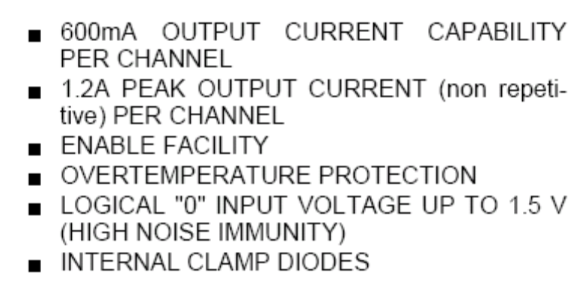

The pin connections and block diagram of L293D is as given below:

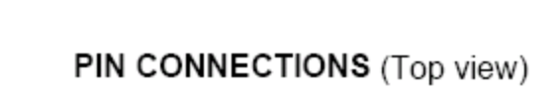
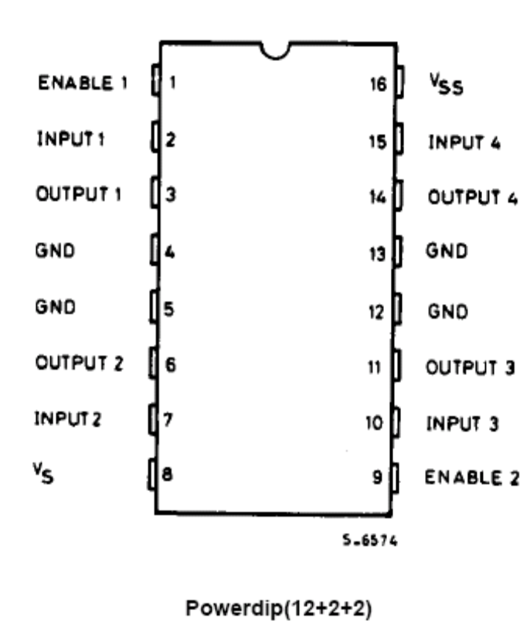
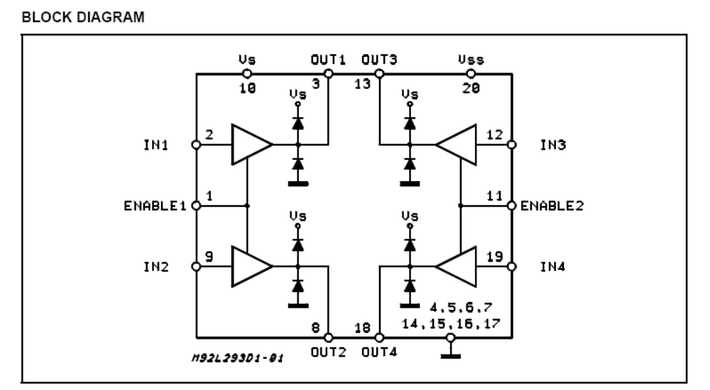

The table below provides the absolute maximum ratings for the L293D IC:
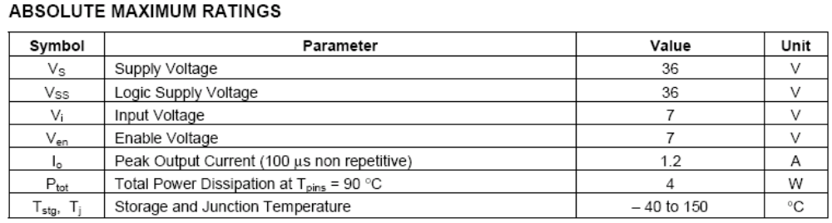
  - IC L298N
The L298 is an integrated monolithic circuit in a 15-lead Multiwatt and PowerSO20 packages. It is a high voltage, high current dual full-bridge driver designed to accept standard TTL logic levels and drive inductive loads such as relays, solenoids, DC and stepping motors. Two enable inputs are provided to enable or disable the device independently of the input signals. The emitters of the lower transistors of each bridge are connected together and the corresponding external terminal can be used for the connection of an external sensing resistor. An additional supply input is provided so that the logic works at a lower voltage.

The specifications for L298N are:
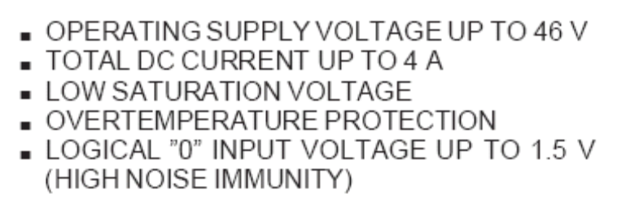
The pin connections and block diagram of L298N is as given below:
PIN CONNECTIONS
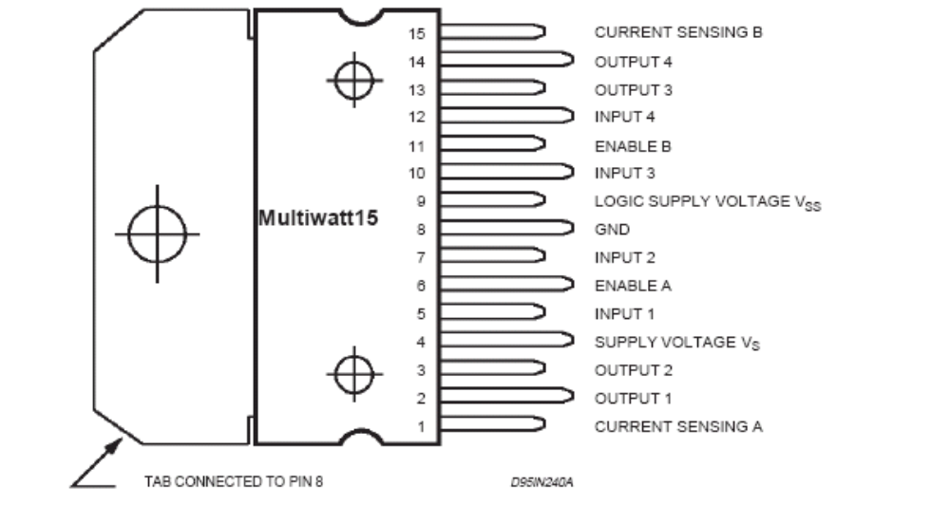
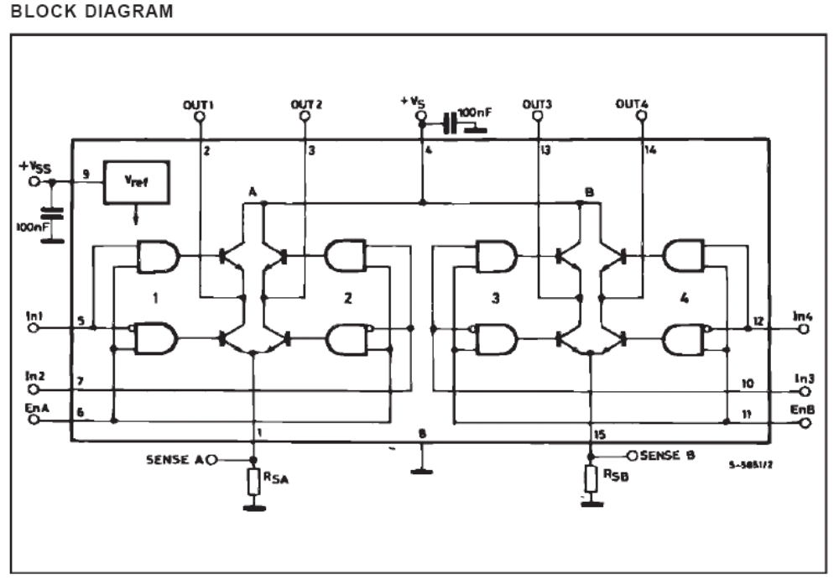

The table below provides the absolute maximum ratings for the L298N IC:
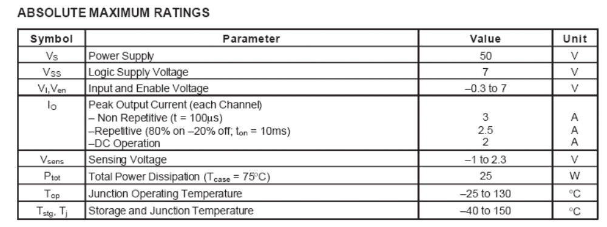
  - IRFZ44N N- Channel MOSFET
The IRFZ44N is an N-Channel MOSFET which is used in electrical circuits which draws a lot of current. The MOSFET consists of 3 pins – The Gate, Drain and Source.
The specifications of this MOSFET are:
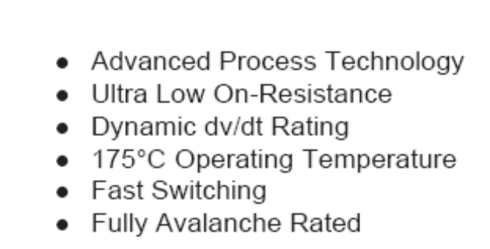
The schematic for the MOSFET along with its TO-220AB package is given below:
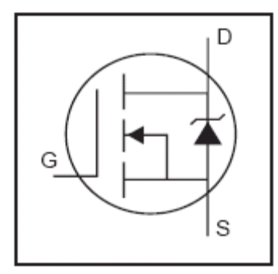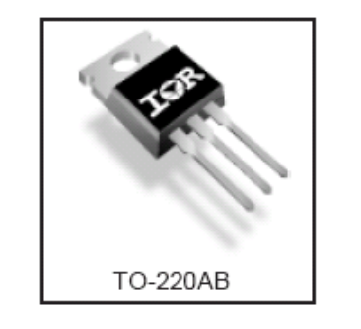
The absolute maximum ratings for IRFZ44N are as shown below:
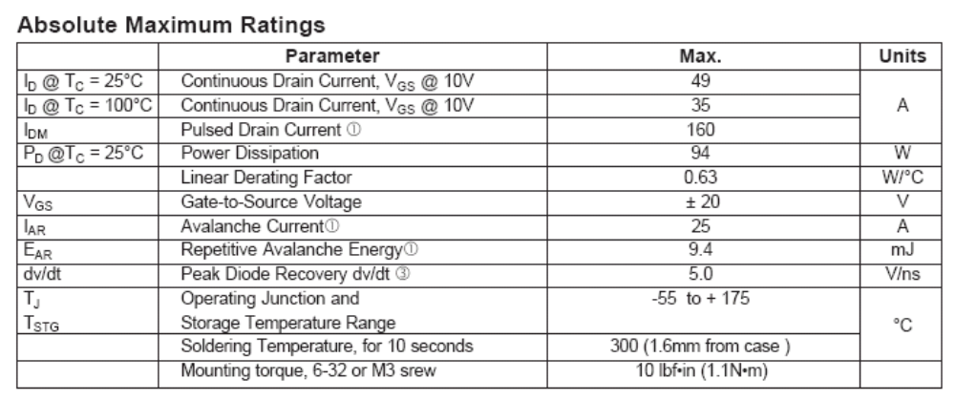
  - The Power Supply Schematic and Specifications
The power supply used to drive the stepper motors is a DC regulated power supply obtained from a transformer. The transformer can supply 15Volts of AC current which needs to be rectified using 4 diodes since it is a 0-15 transformer. The diodes used to rectify the voltage are IN4007 and IN5408 diodes. Filter capacitors are required to obtain non-pulsating DC current since the output voltage obtained from the Diodes is pulsating. Filter capacitor 2200/25V and Capacitors 100kpf/104 are used to obtain non-pulsating DC voltage. Voltage regulator IC’s like LM7812 and LM7805 can then be connected to obtain a specific value of voltage.
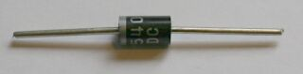
(IN5408 diode)
The schematic for the power supply is as shown below:
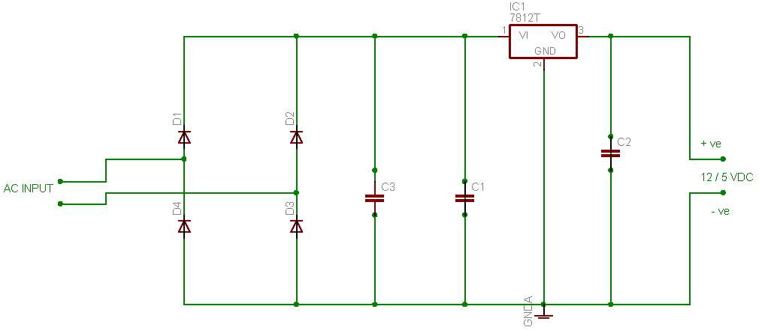

The specifications for the LMXX series IC are given below:
The LM78XX series of three terminal regulators is available with several fixed output voltages making them useful in a wide range of applications. One of these is local on card regulation, eliminating the distribution problems associated with single point regulation. The voltages available allow these regulators to be used in logic systems, instrumentation, HiFi, and other solid state electronic equipment. The LM78XX series is available in an aluminum TO-3 package which will allow over 1.0A load current if adequate heat sinking is provided. Current limiting is included to limit the peak output current to a safe value. Safe area protection for the output transistor is provided to limit internal power dissipation. If internal power dissipation becomes too high for the heat sinking provided, the thermal shutdown circuit takes over preventing the IC from overheating.

Features
  - Output current in excess of 1A
  - Internal thermal overload protection
  - No external components required
  - Output transistor safe area protection
  - Internal short circuit current limit
  - Available in aluminum TO-3 package

The connection diagram for the LM78XX series is as given below:
Connection Diagram
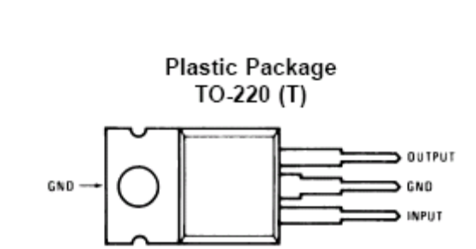

The absolute maximum rating for the series is as given below:
Input Voltage:
(VO = 5V, 12V and 15V) 35V
Internal Power Dissipation: Internally Limited
Operating Temperature Range (TA): 0°C to +70°C
Maximum Junction Temperature:
(T Package) 150°C
Storage Temperature Range: −65°C to +150°C
Lead Temperature (Soldering, 10 sec.):
TO-220 Package T 230°C
Stepper Motor Specifications

- Motor 1 (Base Motor)

Model: 23LM –C005
Step Angle: 1.8 degree
Voltage Rating: 12Volts
Current Rating: 0.44 A/phase
Torque: 5.5 Kg/cm

The resistance of the coils with respect to the common coils is given in the table below:

Common Wire: Black (Pink/Pink White) and White (Green/Green White)

Colour of Wire | Coil Number | Common Wire | Resistance across common
Pink | Coil 1 | Black | 23.2
Green | Coil 2 | White | 22.8
Pink White | Coil 3 | Black | 23.5
Green White | Coil 4 | White | 23.3

- Motor 2(Shoulder Motor)

Model: AstroSyn Stepper
Step Angle: 1.8 degree
Voltage Rating: 12 Volts
Current Rating: 0.4 A/phase
Torque: 2-3 Kg/cm

The resistance of the coils with respect to the common coils is given in the table below:

Common Wire: Brown (Red/White) and Blue-Brown (Blue/Yellow)

Colour of Wire | Coil Number | Common Wire | Resistance across common
Red | Coil 1 | Brown | 32.4
Blue | Coil 2 | Blue-Brown | 32.8
White | Coil 3 | Brown | 32.5
Yellow | Coil 4 | Blue-Brown | 32.8

- Motor 3 (Gripper Motor)

Model: N/A
Step Angle: 1.8 degree
Voltage Rating: 12 Volts
Current Rating: N/A
Torque: 2 Kg/cm
The resistance of the coils with respect to the common coils is given in the table below:

Common Wire: Blue (Yellow/Orange/Red/Green)

Colour of Wire | Coil Number | Common Wire | Resistance across common
Yellow | Coil 1 | Blue | 73.5
Orange | Coil 2 | Blue | 73
Red | Coil 3 | Blue | 73.5
Green | Coil 4 | Blue | 72.6

- Motor 4 (Discarded Shoulder Motor)

Model: 16PU - M301 - G1
Step Angle: 1.8 degree
Voltage Rating: 12 Volts
Current Rating: 1.5A
Torque: 3 Kg/cm

NOTE: The resistances for the coils could not be measured as the coils were burned up due to the excessive heat from welding.

- The software design and development for the robotic arm.
The software control of the robotic arm provides the user with a control window. On this control window are command buttons which let the user maneuver the arm to a desired location.
A USB camera connected to the PC gives a live video feed of the entire field of the robotic arm. So the user can optionally look at this screen and operate the robotic arm.
At the start of the application the user can also provide the necessary parallel port addresses.

The overall software design for the system comprises of the following modules and technologies:

- INPOUT32.DLL – Used for interfacing with the parallel port.
- Java Native Interface (JNI) – This consists of making a DLL which establishes a link between the Java program and the native code written in C. Integration between the Java program and the native code is done using the Java Native Interface (JNI).
- The Native Code Implementation in C - The functions used to interface the parallel port using INPOUT32.DLL are written in C
- Java Application – It consists of the complete GUI and programming logic designed using Java Swings
- USB Webcam Interfacing – This involves using Java Media Framework (JMF) to obtain video feed into the Java application.

All the above mentioned modules and a brief overview of the technologies associated with each module are given in the section ahead.

The following images show the flow of the entire system:
START
Input LPT addresses
LPT addresses Correct?
NO
ALERT USER!
YES
Load Manual Control Window
X
Load USB webcam Video feed
Y
X
Choose Motor and Stepping Mode
Choose Direction Control
On Click invoke Native methods
Native Methods repository
Output pulse(s) to LPT port(s)
BACK
EXIT
Y
Deallocate Camera Resources & Reset Parallel Port(s).
END
- The INPOUT32 DLL :
Writing programs to talk with parallel port was pretty easy in old DOS days and in Win95/98 too. We could use Inporb and outportb or _inp () or _Outp functions in our program without any problem if we are running the program on DOS or WIN95/98. But entering to the new era of NT clone operating systems like WIN NT4, WIN2000, and WINXP, all this simplicity goes away. When we are trying to run a program which is written using the conventional software functions like Inporb, outportb, _inp() or _Outp on a WINNT or WIN2000 system, it will show an error message that "The exception privileged instruction occurred in the application at location ....". The picture of such a messagebox is given below.
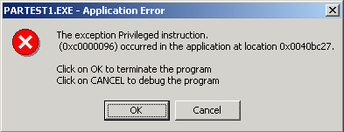

The solution to this problem is the INPOUT32 DLL.
Some of the features of this DLL are as follows:
• Works seamlessly with all versions of windows (WIN 98, NT, 200 and XP).
• Uses a kernel mode driver embedded in the dll.
• No special software or driver installation required.
• No special APIs required only two functions Inp32 and Out32
• Can be easily used with VC++ and VB.

Working of the INPOUT32 DLL:
The outstanding feature of Inpout32.dll is that it can work with all the windows versions without any modification in user code or the DLL itself. The Dll will check the operating system version when functions are called, and if the operating system is WIN9X, the DLL will use _inp () and _outp functions for reading/writing the parallel port. On the other hand, if the operating system is WIN NT, 2000 or XP, it will install a kernel mode driver and talk to parallel port through that driver. The user code will not be aware of the OS version on which it is running. This DLL can be used in WIN NT clone operating systems as if it is WIN9X.

The flow chart of the program is given below:

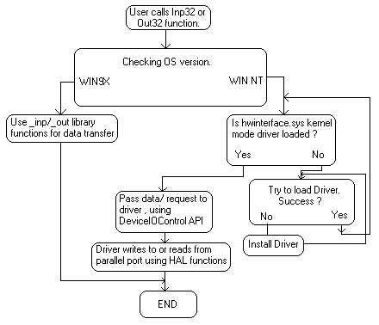

The two important building blocks of this program are
1) A kernel mode device driver embedded in the DLL in binary form
2) The DLL itself
Kernel mode driver Hwinterface.sys
"hwinterfacedrv.c" is the main application source file. Three functions implemented in the driver are:
1) DriverEntry () - Called when driver is loaded. Creates device object and symbolic links.
2) hwinterfaceUnload () - Called when driver is unloaded, performs clean up.
3) hwinterfaceDeviceControl () - Handles calls made through DeviceIOControl API. Performs reading writing to the parallel port according to the control code passed.
The DLL Inpout32
The functions in the DLL are implemented in two source files, "inpout32drv.cpp" and "osversion.cpp". osversion.cpp checks the version of operating system. "inpout32drv.cpp" does installing the kernel mode driver, loading it, writing/ reading parallel port etc... The two functions exported from inpout32.dll are
1) Inp32 (), reads data from a specified parallel port register.
2) Out32 (), writes data to specified parallel port register.
- Java Native Interface (JNI)
The Java Native Interface (JNI) is the native programming interface for Java that is part of the JDK. By writing programs using the JNI, you ensure that your code is completely portable across all platforms.
The JNI allows Java code that runs within a Java Virtual Machine (VM) to operate with applications and libraries written in other languages, such as C, C++, and assembly. In addition, the Invocation API allows you to embed the Java Virtual Machine into your native applications.
Programmers use the JNI to write native methods to handle those situations when an application cannot be written entirely in the Java programming language. For example, you may need to use native methods and the JNI in the following situations:
- The standard Java class library may not support the platform-dependent features needed by your application.
- You may already have a library or application written in another programming language and you wish to make it accessible to Java applications.
- You may want to implement a small portion of time-critical code in a lower-level programming language, such as assembly, and then have your Java application call these functions.
Programming through the JNI framework lets you use native methods to do many operations. Native methods may represent legacy applications or they may be written explicitly to solve a problem that is best handled outside of the Java programming environment.
It is easy to see that the JNI serves as the glue between Java and native applications. The following diagram shows how the JNI ties the C side of an application to the Java side.
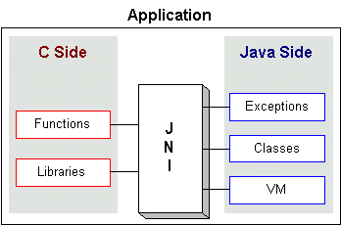

The following example shows how to integrate native methods in Java and the various other steps required:
Writing native methods for Java programs is a multi-step process*
- Create RoboArm.java: Begin by writing the Java program. Create a Java class that declares the native method; this class contains the declaration or signature for the native method. It also includes a main method which calls the native method.
class RoboArm {
private native void print();
public static void main ( String [ ] args ) {
new RoboArm().print();
}
static {
System.loadLibrary ( "robodll" ) ;
}
}
- Compile RoboArm.java: javac RoboArm.java .

- Generate a header file RoboArm.h for the native method using javah with the native interface flag -jni. Once you've generated the header file you have the formal signature for your native method.
javah -jni RoboArm

- Create RoboImpl.c: Write the implementation of the native method in C.
#include <jni.h>
#include <stdio.h>
#include "RoboArm.h"
JNIEXPORT void JNICALL
Java_helloNative_print ( JNIEnv* env, jobject obj ) {
printf ( "Hello, Native!\n" ) ;
return ;
}
- Compile the header RoboArm.h and implementation RoboImpl.c files into a shared library file.

- Run the Java program RoboArm.class: java RoboArm

- Development Stages (Mechanical & Electrical)

The section ahead takes you through the entire course of the project. How it all started? How the mechanical designs were made and altered. Also what were the various problems faced at each stage. The solutions thought for the problems and how it all worked out is a part of the next section. These development stages also play a crucial role in assessing the scope of the project. Each problem had to be tackled with a new solution which meant not only changing the mechanical designs but also altering the entire circuitry on quite a few occasions.

- Interfacing the very first stepper motor.
  - The very first stepper motor purchased was Motor 1 which is currently being used for the shoulder joint.
  - A test circuit was prepared on a project bread-board using ULN2003 IC.
  - The power supply used was designed using the 7812 Regulated supply which got its rectified voltage from 4 IN4007 diodes.
  - Wires were directly attached to the data pins of the parallel port which were given as input to the ULN2003 IC.
The basic circuit used to drive the stepper motor is as given below:

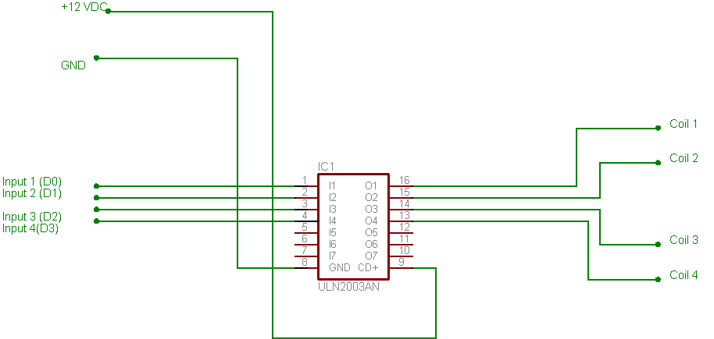

- Building the circuit on a General purpose Parallel PCB
  - Once the stepper motor was interfaced and everything was working, additional stepper motor was purchased.
  - Also the wiring done using the parallel port was very crude. So it was decided to solder the IC’s directly on a General purpose PCB and to mount a DB-25 PCB mounting female connector on the PCB. This facilitated easy removal and insertion of the parallel port cable as and when required.

The image below shows the output obtained after this stage.

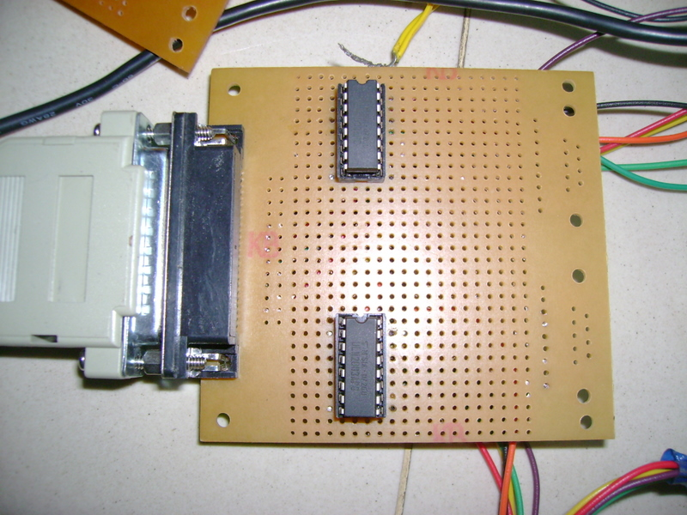

- Choosing the Base Stepper motor

  - Since the entire assembly depended on the base stepper motor, the selection of the base motor was quite essential.
  - The base stepper had to be able to bear the load of the entire assembly.
  - Also in-order to simplify the circuitry it was decided to opt for ULN2803 IC’s as they are able to drive two unipolar stepper motors at a time.
  - A high torque base stepper motor was chosen which could drive loads of nearly 5 Kg.
  - A gripper motor which of 2 Kg torque was also purchased.
The basic schematic of a ULN2803 IC is as given below:
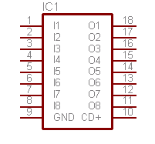

  - Constructing the mechanical assembly
  - The initial arms which were attached to the stepper motor were made from Aluminum strips used in sliding window channels. Although it was light weight, the motor was unable to bear the load.
  - The next approach was to fabricate arm using stainless steel strips. A 10 inch stainless steel rod was weld to the base stepper motor.
  - The other end of this strip was strategically cut so that the shoulder motor can be mounted on it using screws.
  - Once the shoulder motor was mounted, another stainless steel strip was weld to the output shaft of the shoulder motor.
  - The other end of this strip had an arrangement on which the gripper motor could be mounted.
  - The gripper for holding onto objects is comprised of a fixed strip on the gripper motor and an aluminum strip on the gripper motor output shaft.
  - This entire assembly of three motors was mounted on a base which comprised of a wooden plank.
  - On this wooden plank 4 strips of wood were nailed which aligned with the four corners of the base stepper motor.
  - This arrangement made sure that the base stepper motor was affixed on the wooden plank.
  - The base stepper was mounted on the wooden plank in such a manner that it countered the weight of the entire assembly. This arrangement prevented it from toppling over.

Given below are some images which show the construction process for the mechanical assembly:

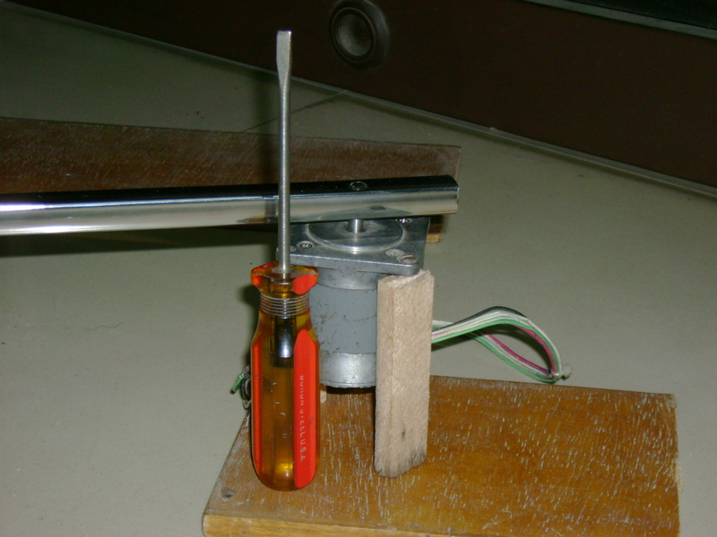

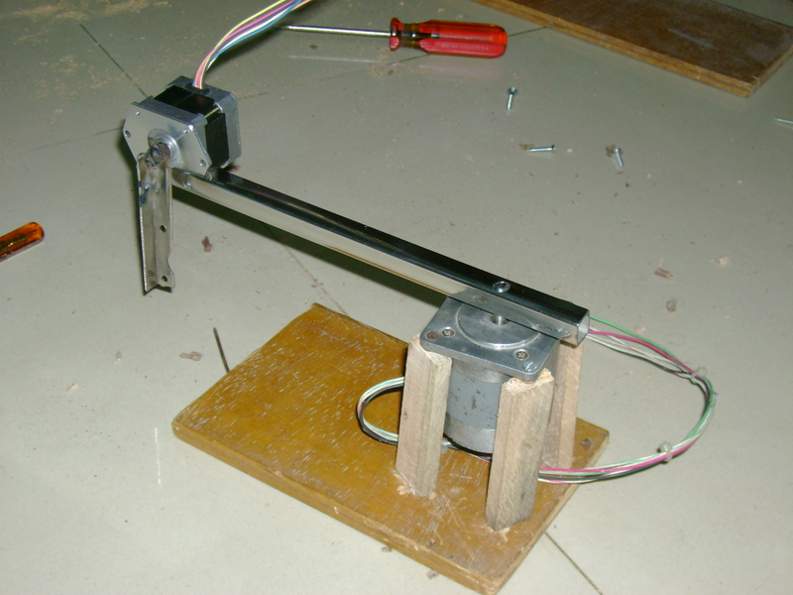

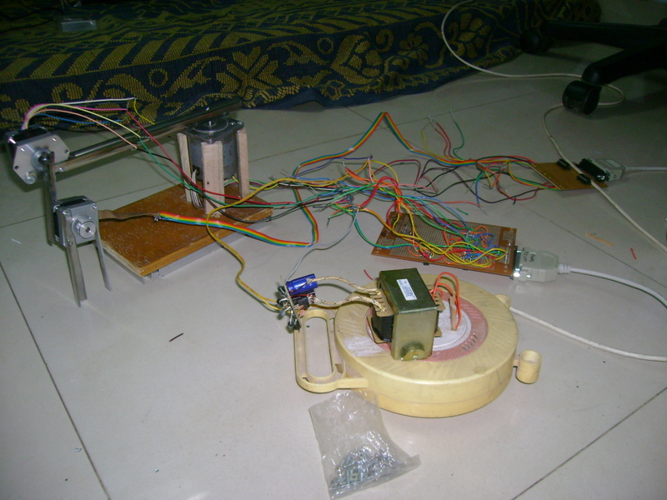

  - Problems faced in this stage and their solutions:

  - The base constructed was not at an adequate height and due to this the gripper stepper motor could not orient itself properly. So aluminum strips were cut and glued under the wooden plank which provided it sufficient elevation.
  - At this stage the shoulder motor proved to be a big mistake. As the stainless steel was directly mounted on the output shaft of the motor, the current drawn by this motor became too huge for the ULN2003 and ULN2803 IC’s to handle.
  - The motor was drawing around 1.5 A of current when the maximum capacity of the ULN2003 and ULN2803 IC’s is just 500mA per channel.
  - In-order to overcome this problem an alternate IC L293D was chosen which could provide around 600mA per channel. The entire circuit required to drive a unipolar stepper motor using this IC is given at the end of this section.
  - In spite of using this IC the problem was not solved. The shoulder stepper motor would lift up the stepper momentarily and then just give up. Since it was drawing way too much current the L293D’s were getting heated up and the internal thermal protection mechanism would switch off the IC.
  - In-order to gain even higher current without changing the circuitry much, it was decided to connect two L293D in parallel. The entire circuit to drive a stepper motor using L293D connected in parallel is given ahead.
  - This approach worked but the IN4007 diodes on the power supply board started to heat up and burnt.
  - In-order to over come this, much more efficient diodes IN5408 was used.

The images show a test circuit of two L293D connected in parallel on a project board and the modified power supply board using IN5408 diodes:

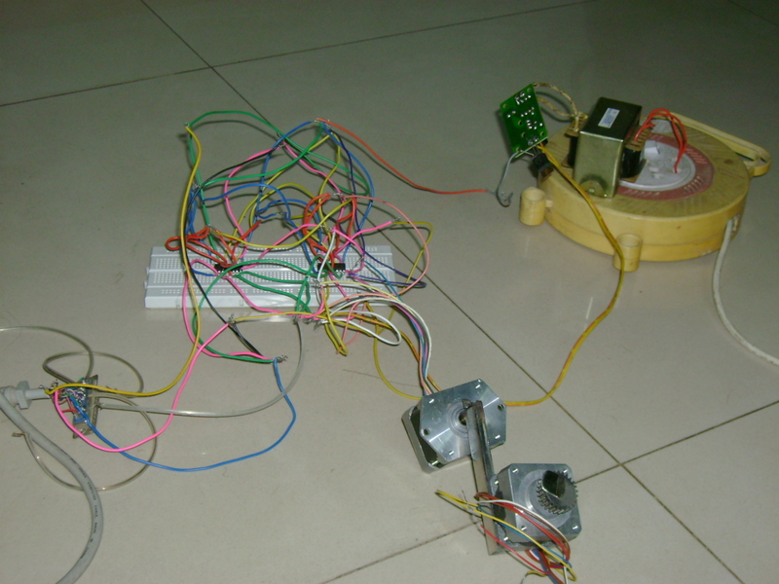
(Test circuit showing two L293D in parallel)

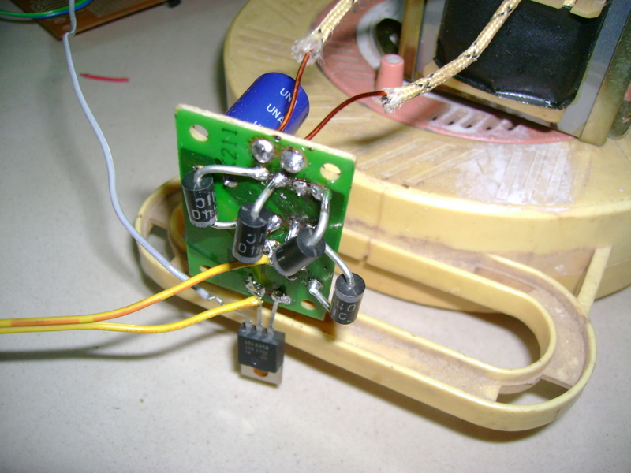
(Image showing modified power supply using IN5408 diodes)

  - This arrangement made the shoulder motor lift up the gripper for quite some time but the overheating problem of the L293D’s still persisted.
  - Another idea was used to try and use high current N channel MOSFETS. These devices are capable of bearing good amount of current. The outputs of the paralleled L293D were given to four N-Channel MOSFETS. The MOSFETS used were IRFZ44N.
  - The IRFZ44N consists of three pins, The Gate, Drain and Source.
  - The L293D outputs were connected to the Gate, The source was connected to the ground and the drain was connected to one of the coils of the stepper motor.
  - Connecting the MOSFETS solved the heating problem of L293D, but this gave rise to another problem. The MOSFETS were themselves getting heated up!
  - As a last resort it was decided to go with L298N IC which has a current rating of around 2A per channel. But introducing this IC meant changing all the circuitry.
  - Also handling the L298N IC is not an easy job, leaving aside its high cost.
  - The IC was however soldered on the general purpose PCB.
  - Since the legs of this IC won’t go into the PCB a 40x1 flow solder was used on which the IC was mounted.
  - After building the entire circuitry the IC failed to work. There may be many reasons as to why this was not working. Even after repeated checks it was hard to arrive at a conclusion so as to why this IC won’t work. One possibility was that the current from the parallel port was not enough to drive the motors using the IC.

A general schematic of the L298N IC is as given below:

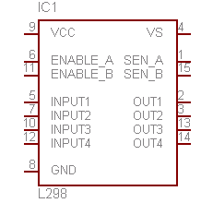
  - The main problem at this stage was that the shoulder motor coils had been burnt due to excessive head from welding. No matter what approach was taken; it would have not solved the problem.
  - Both time and budget were a scarce resource at this juncture.
  - At this point of time it was decided to do away with the shoulder stepper motor and redesign the mechanical assembly. Something had to be done with the spare motor initially purchased.
  - A fulcrum based pivoting approach was thought of. This is explained ahead.

  - The Fulcrum and Pivot Approach

- In this approach the initial stepper motor purchased was mounted at the end of the horizontal shaft where the shaft was weld to the base motor.
- The shoulder motor was detached and was replaced by a horizontal bar which would act as a fulcrum.
- This fulcrum was pivoted at the end of the link connecting the base.
- A nylon thread was attached to the top of this horizontal bar and the other end of the thread was tied to the output shaft of the newly mounted stepper motor.
- Now as the stepper motor rotated in one direction, the thread would wound up on the output shaft of the motor and the fulcrum would be pulled down.
- To the other end of the fulcrum bar the gripper motor was attached. This gripper motor would be pulled up.
- Reversing the stepper motor led to the unwinding of the thread and the gripper motor was moved down.

The image below shows this arrangement:

